Module Assembly - TC Cockpit Project Milestones Management Front End Deployment Guide

Revision History
Author | Revision Number | Date
TCSASSEMBER | 1.0 | 02/29/2012

Deployment Instructions 3
1. Organization of Submission 3
2. Application Setup 3
2.1 Ant .Properties File 3
2.2 Build Scripts Setup 3
3. Database Setup 4
4. Deployment Instructions 4
5. Starting 4
6. Verification 4
7. Resource Contact List 5

Deployment Instructions

Organization of Submission

The submission follows directory structure provided below:

doc
Contains the Deployment Guide Document of this assembly.

direct
Contains sources and static files for Direct web application. This directory replicates the application development distribution structure and includes only updated and new files.
- topcoder_cockpit_project_milestone_services
The updated TopCoder Cockpit Project Milestone Services component
db_scripts
Contains all the newly added / updated DDLs and queries for updating database script trunk
query
Contains all the newly added query : query_has_milestone_write_permission.txt
test_files
Contains the SQL files to insert user ratings and update the schema to insert new column : completion_date

Application Setup

The application is expected to be deployed to the following environment:

JRE 1.5
JBoss 4.2.3.GA
Informix DS 11.5

Ant .Properties File

No .properties files are modified.

Build Scripts Setup
The ANT build script for Direct application (build.xml) provides the following targets which are to be used:

- switch-and-checkout – checkout or switch to the defined source code branches for all components defined in subprojects.xml
- dist-backend – rebuilt all the components from the source code.
- first_deploy – must be the first task to execute from command line. It will copy all dependencies to your local JBoss folder.
- deploy – should be the main task to execute from command line. It will build and deploy WAR file.
- deploy-static-files – deploys the static files to JBOSS.
- deploy-apache-static – deploys the static files to apache server on VM.

Please refer here for more information:
http://www.topcoder.com/wiki/display/docs/TC+Direct+Setup+Guide

Database Setup

Add new metadata keys for project ratings
- Run test_files\add_completion_date_column.sql on database

Update and add queries via Query Tool

Log into the TC Query Tool to add the new query (on VM use http://tc.cloud.topcoder.com/query/query)

Add new query has_milestone_write_permission
- Choose the database TCS_CATALOG
- Create new query has_milestone_write_permission, click edit
- Paste the new query in query/ query_has_milestone_write_permission.txt and Save
- Click a new “New Input”
  - Description: milestone id
  - Code: mid
  - Data Type: Integer Input
- Assign the input @uid@ and @mid@ to the new query created
- Add a new command : has_milestone_write_permission
- Add the new query to this new command

Deployment Instructions

This section provides the instructions in Production environment.

- Merge the code from submission into SVN for Direct application, all the files in the direct directory.
- Go to the directory topcoder_cockpit_project_milestone_services, run dist-tcs to rebuild the component
- Go the direct base directory
- Build and deploy Direct application using ant deploy (or ant first_deploy ) command.
- Copy static files using ant deploy-static-files command or ant deploy-apache-static if use apache as static file server.

Starting

- Build and deploy the Direct application
- Start JBoss server instance hosting Direct application

Verification

Set up test data first, run the following SQL scripts in order against the test server database to add ratings for all the users:
- test_files/insert_user_ratings.sql

Create a new project with “Start Your New Project Now” button and go the project overview JSP after creation.

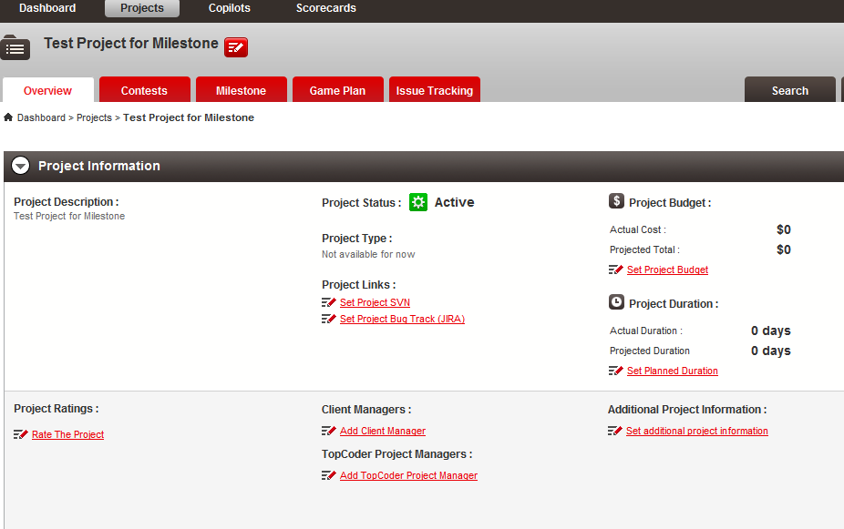

Click the milestone tab

There is no milestone for empty project. Click Edit Project button to add responsible person for the project

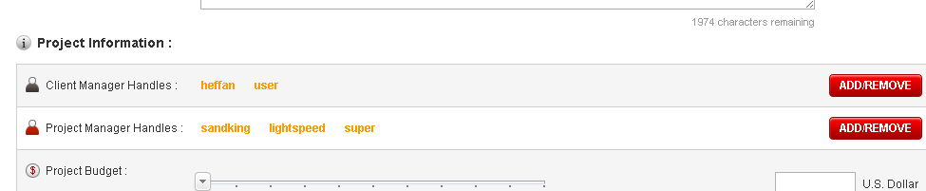
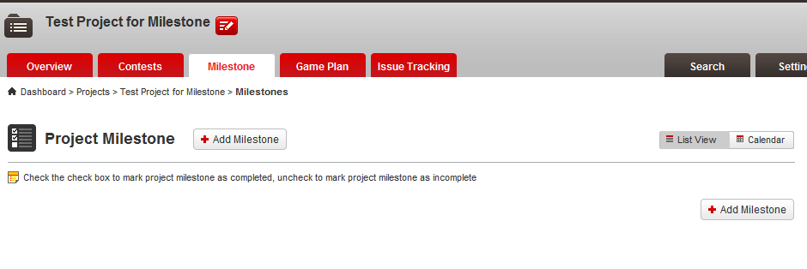

Hover over “Add Milestone” and choose Single Milestone

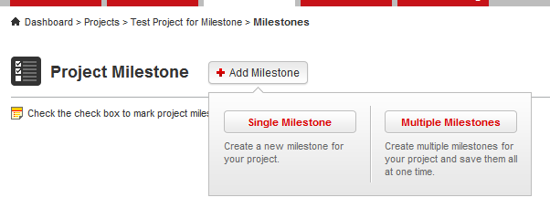

A modal window is displayed for you to enter the new milestone data

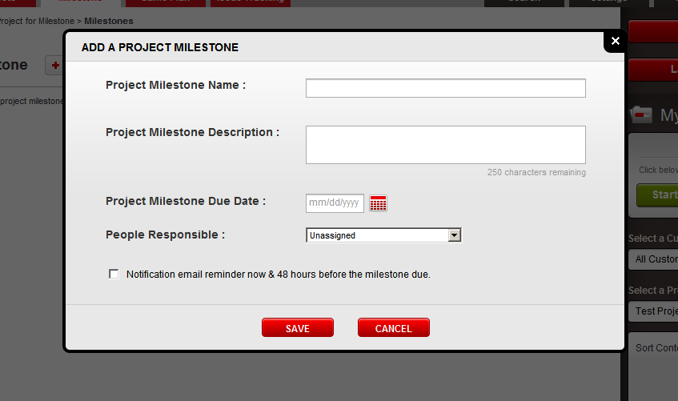

Check Save without entering data

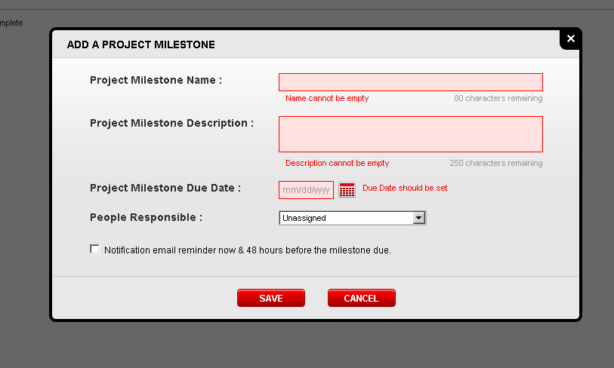

Enter the needed data and click save

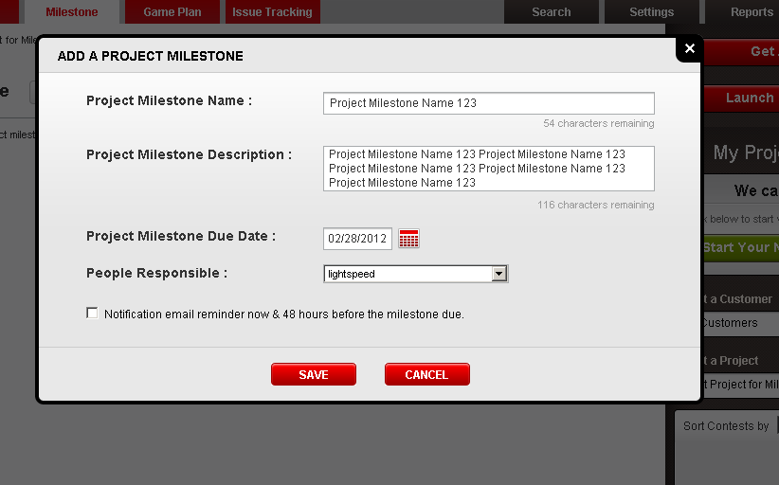

The milestone is created and inserted

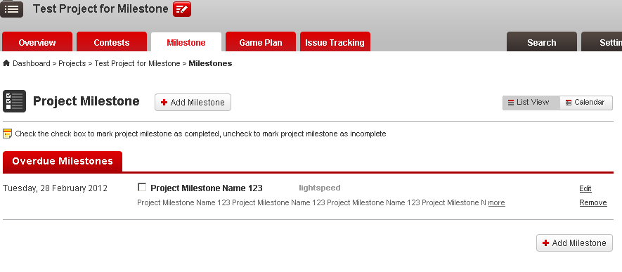

Add more milestones if you like

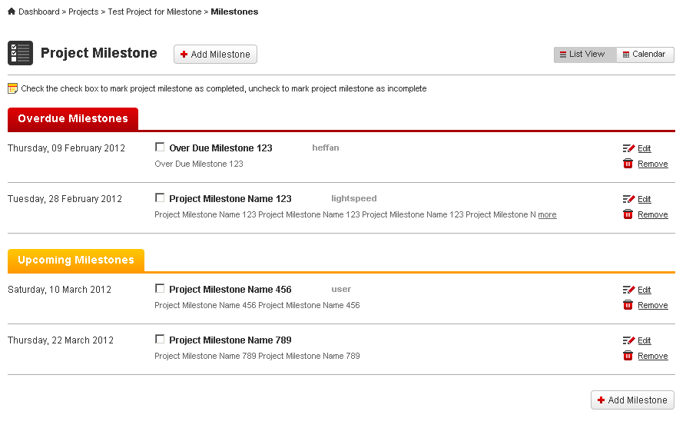

Check the checkbox of first milestone

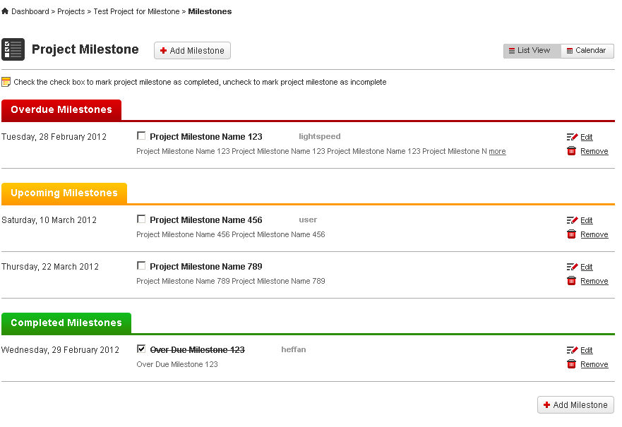

Uncheck it to mark as uncompleted

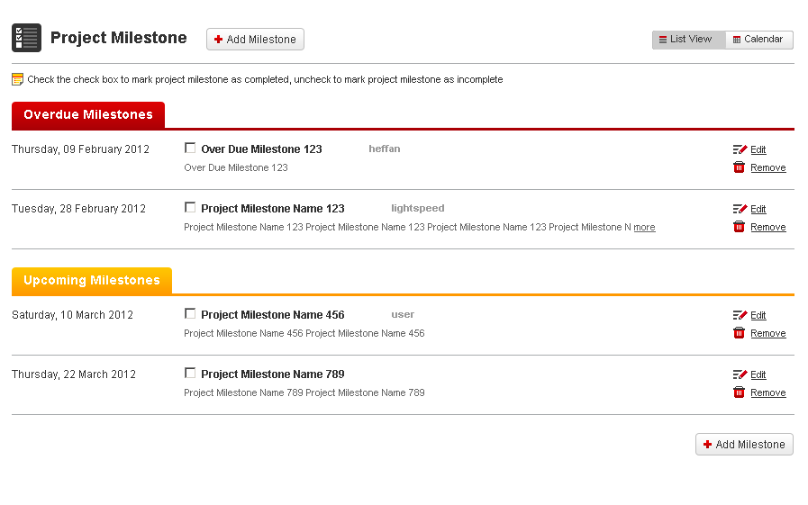

Mark them all as completed

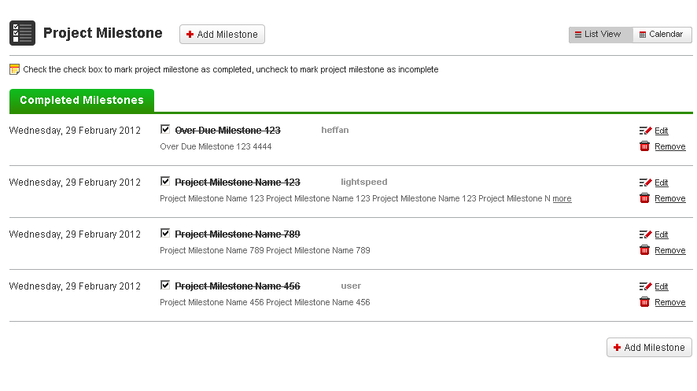
Click edit button to edit the milestone

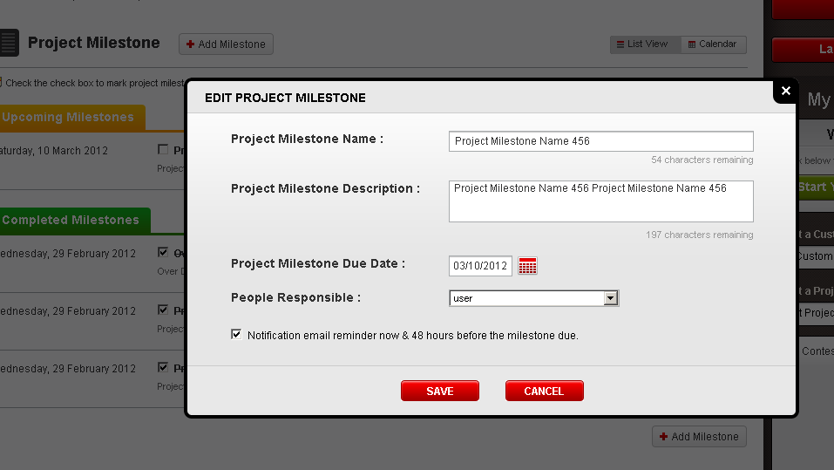

Update the due date

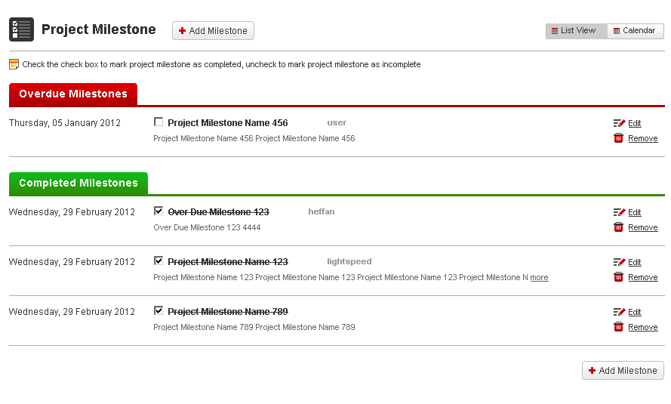

Click the remove button

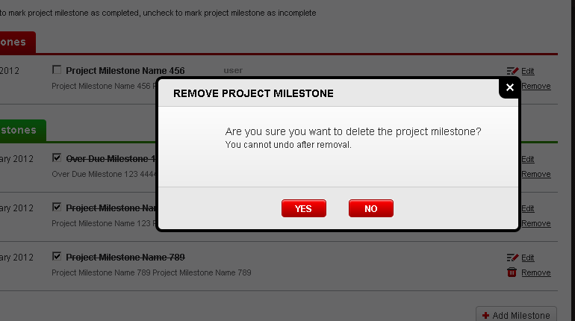

A confirmation window should be displayed, click “YES” to delete

It’s deleted

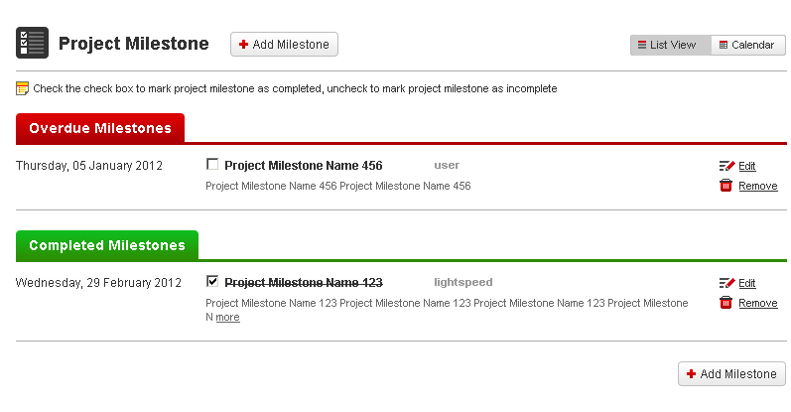

Click Add Milestone and choose Multiple Milestones

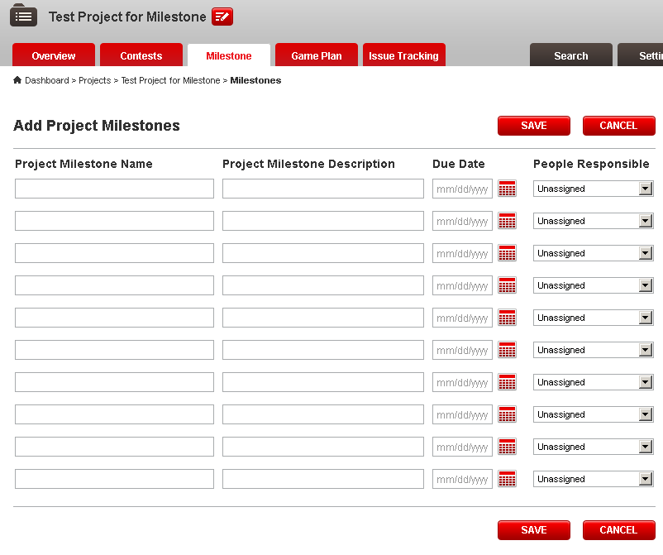

Enter some incompleted data into the row and click Save, missing fields are all highlighted

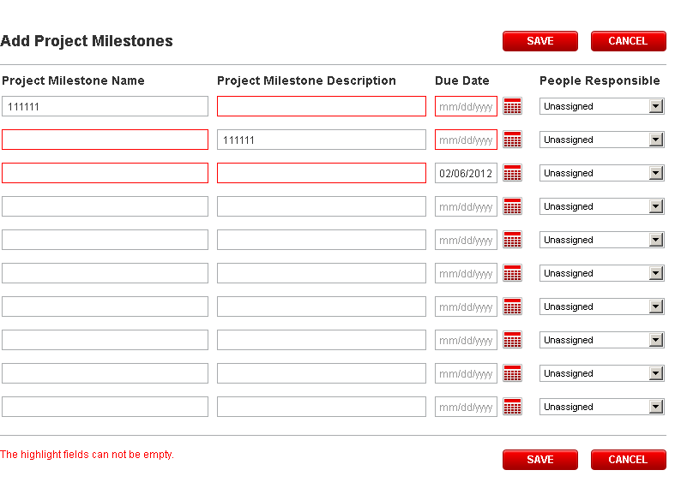

Fill the data and click save again

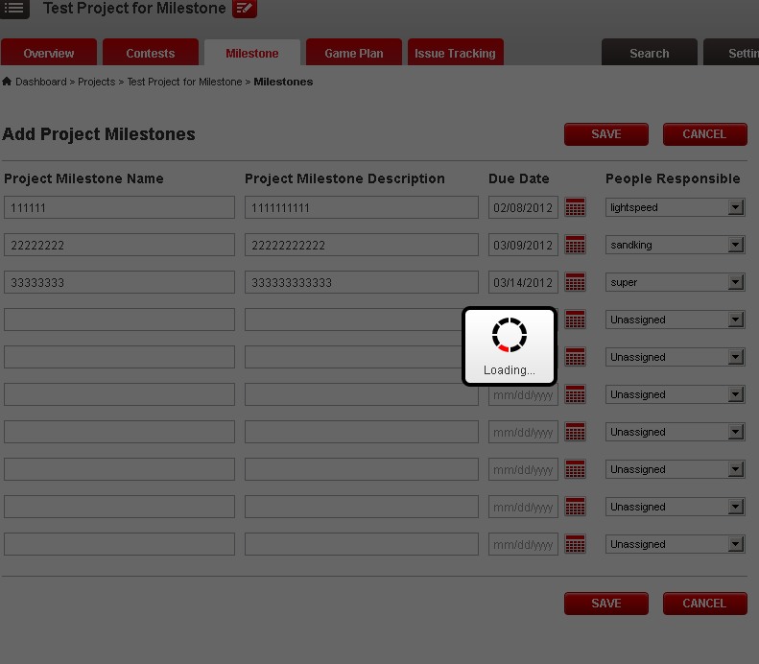

And then redirects to the list view page

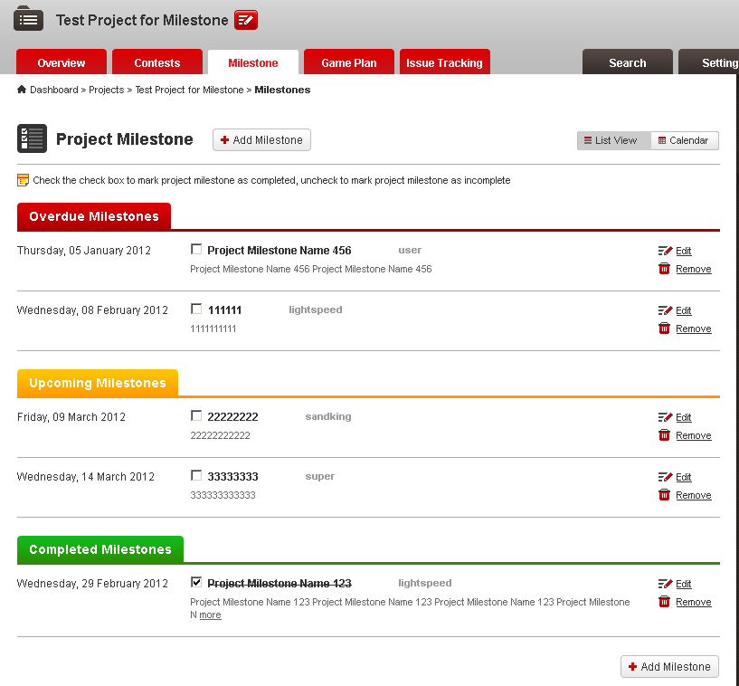

Click the calendar button to view calendar view

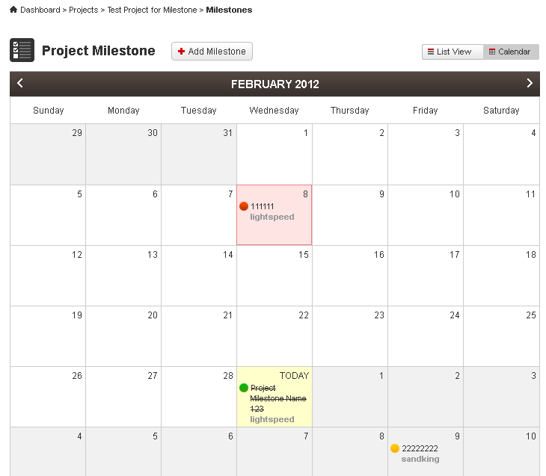

Create a new milestone in this page

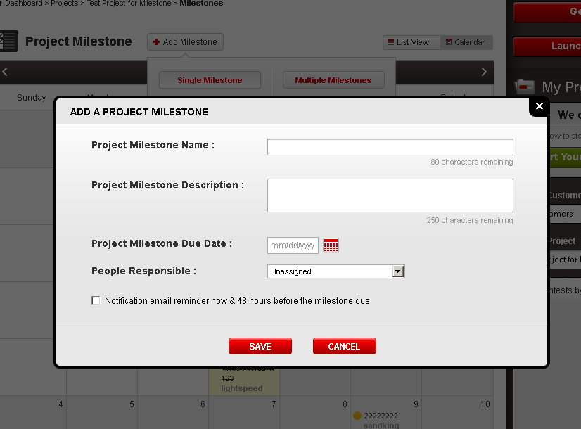

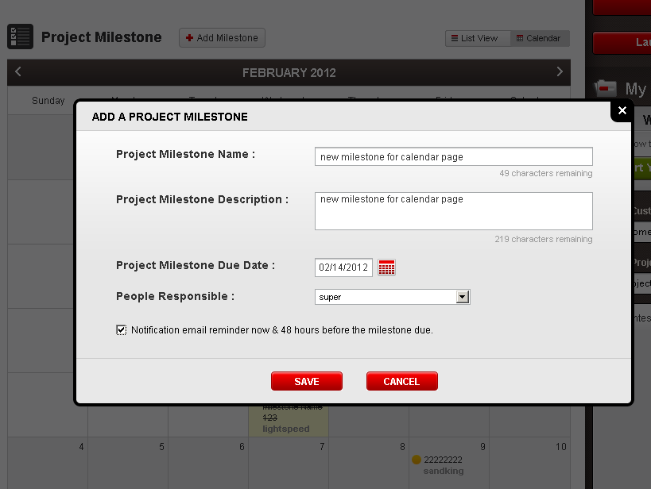

Then click save

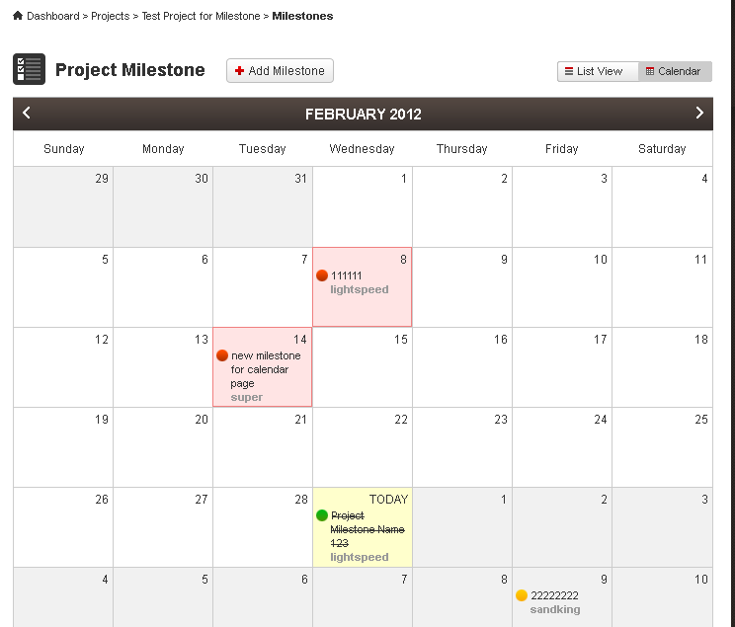

The calendar is loaded with the new data.

Resource Contact List

Name | Resource Email
TCSASSEMBER

